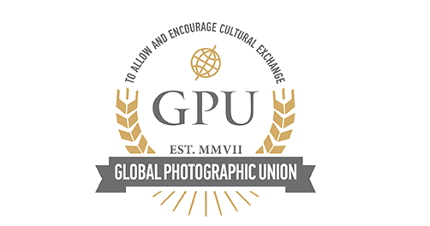
Dear members,
We are starting with the preparations for the NEW GPU PHOTO BOOK!
This is our biannual edition in which every member is presented with his/hers photos.
You are invited to send 4 photos to gpu_china@aliyun.com, from which 2 photos will be chosen for the book.
Instructions:
Photos should be in JPEG format, with 1500 pixels MINIMUM on the SHORT side, in 300 dpi resolution.
Name of the photos: surname-name-title of the photo.jpeg.
In the message with the photos PLEASE write your NAME and surname, photo distinctions (optional) and your country.
You can send your photos by email or by wetransfer.com, depending on the file size.
The deadline for sending is 28. September 2017.
The book will be prepared and sent to all members by the end of the year.
All the photos received will be kept in GPU’s photo archive and will (or might) be displayed in future GPU's printed exhibitions, GPU website and profile on social networks (Facebook and Instagram), with the only purpose to promote photography of GPU’s members and GPU association.

If you would disagree with any of these publications of your photos, please note in your message.
See you in the book!
Best regards,
Global Photographic Union

以下为翻译件

尊敬的各位会员，

我们开始筹备编辑新版GPU画册！

这是我们的半年刊画册里面收入每位会员的代表作。

现邀请你发送4幅作品之gpu_china@aliyun.com，从中将会有2幅作品选入画册。

说明：
作品必须是JPEG格式，短边不得小于1500,300dpi.

作品命名：姓-名-作品名.jpg
请注明你的姓名，荣衔（自愿）和国家名。

可以通过邮件或者wetransfer发送作品，这取决于文件的大小。

截稿日期是：2017年9月28日

这本画册将于年底寄给每位会员

所有收到的作品将存入GPU图片档案里，或许将来用于GPU的展览，以及GPU网站等社交媒体上（Facebook和Instagram），目的仅限于推广宣传GPU的会员作品和GPU团体。
如果你不同意在以上的任何场合公开你的作品，请在留言里注明。

希望在画册里看到你的作品！

祝好

国际摄影家联盟

